Santiago Paz  
October 17, 2014

Financial Case Study

Professor Von Deak

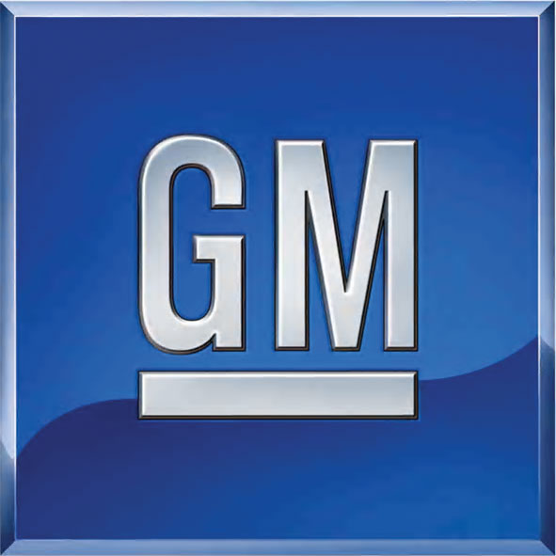

I have read and understand the academic honesty policy as outlined in the syllabus and the student handbook.  By affixing this statement to the title page of my paper, I certify that I have not cheated or plagiarized in the process of completing this assignment.  If it is found that cheating and/or plagiarism did take place in the writing of this paper, I understand the possible consequences of the act/s, which could include, but are not limited to a ZERO for this assignment and a failing grade for the course.

The company I analyzed for a financial case study was General Motors. General Motors was founded on September 16, 1908 in the famous industrial town of Flint, Michigan. It was originally a business that was created to buy and hold shares of other companies; also known as a holding company. While General Motors slowly began to acquire more automotive companies, they were also experiencing ownership issues. They were able to survive and move past these issues to become the General Motors that we know of today. The following information delineates the changes GM has gone through over the course of two years.

|  |  |  |  |  |  |  |  |  |  |
| --- | --- | --- | --- | --- | --- | --- | --- | --- | --- |
| Current Ratio (Liquidity) | Current Assets |  | $69,996.00 | 1.30 |  | $81,501.00 | 1.31 |  | 1.36 |
|  | Current Liabilities |  | $53,992.00 |  |  | $62,412.00 |  |  |  |
|  |  |  |  |  |  |  |  |  |  |
| Debt to (Owner's) Equity Ratio | Total Liabilities |  | $112,422.00 | 7.02 |  | $123,170.00 | 4.48 |  | 1.37 |
|  | Owner's Equity |  | $16,004.00 |  |  | $27,509.00 |  |  |  |
|  |  |  |  |  |  |  |  |  |  |
| Profit Margin (Return on Sale) | Net Income |  | $6,188.00 | 4.12% |  | $5,346.00 | 3.51% |  | 4.79% |
|  | Sales |  | $150,295.00 |  |  | $152,092.00 |  |  |  |
|  |  |  |  |  |  |  |  |  |  |
| ROI - Return on Equity | Net Income after taxes |  | $4,859.00 | 30.36% |  | $3,770.00 | 13.70% |  | 12.95% |
|  | Total Owner's equity |  | $16,004.00 |  |  | $27,509.00 |  |  |  |
|  |  |  |  |  |  |  |  |  |  |
| Inventory Turnover | Sales |  | $150,295.00 | 10.21 |  | $152,092.00 | 10.83 |  | 9.72 |
|  | Inventory |  | $14,714.00 |  |  | $14,039.00 |  |  |  |
|  |  |  |  |  |  |  |  |  |  |
| Acid Test Ratio | Current Assets - Inventory |  | $55,282.00 | 1.02 |  | $67,462.00 | 1.08 |  | 1.05 |
|  | Current Liabilities |  | $53,992.00 |  |  | $62,412.00 |  |  |  |

|  |  |  |  |  |
| --- | --- | --- | --- | --- |
| **Financial Data** | **Dec 31 2012** | **Dec 31 2013** | **% Change** | **Actual Change** |
| Sales | $150,295.00 | $152,092.00 | 1% | $0.01 |
| Cost of Sales (COGS) | $130,386.00 | $133,538.00 | 2% | $0.02 |
| Gross Profit | $17,511.00 | $18,823.00 | 7% | $0.07 |
| Net Income (Loss) | $6,188.00 | $5,346.00 | -16% | -$0.16 |
|  |  |  |  |  |
| Inventory | $14,714.00 | $14,039.00 | -5% | -$0.05 |
| Cash | $686.00 | $1,247.00 | 45% | $0.45 |
| Total Current Assets | $69,996.00 | $81,501.00 | 14% | $0.14 |
| Long Term Debt (part of total liability) | $3,424.00 | $5,762.00 | 41% | $0.41 |
| Total Equity (Stockholders) | $37,000.00 | $43,174.00 | 14% | $0.14 |
| Total Assets | $149,422.00 | $166,344.00 | 10% | $0.10 |

According to the information provided above, the sales number increased through the span of two years. A sales increase is a great sign of improvement for a somewhat troublesome company. After losing Hummer as well as vehicles from other American companies, GM was in a huge struggle, and has gone to fight past this with slow improvement. One downside in the increase of sales is the increase in the cost of sales. An increase in the cost of sales should not be a problem as long as they make up for it in their sales, and GM’s gross profit did end up rising at the end of the year. The gross profit is not the whole picture because the net income is what represents how the firm was doing over a period of time. Along with cash, the firm’s current assets ended up rising. Since the long-term debt also rose, the company could have decided to finance its operations through equity debt since the number of stockholders also increased.

In the world of business, the liquidity of an asset refers to how quickly it can be converted to cash. A current assent has to have liquidity of a year or less to be considered liquid, otherwise it would be considered an illiquid asset. According to the group of liquidity ratios from 2012 and 2013, there was an increase from 1.30 to 1.31. Knowing the current ratio is important for a firm, because it will let them know that they have a safety cushion if their liabilities exceed their asset intake.

When a company wants to know how much they are able to retain from their earnings, they use their profit margin. Profit margin also can show how much money a company makes off a product, and for the auto industry, it is typically how much money the company makes off a give vehicle. Between 2012 and 2013, GM’s profit margin decreased. A decrease in profit margin increases a company’s likelihood of reaching bankruptcy in the long term as well as risking their liquidity.

A firm sometimes needs to borrow money, which can lead to debt if not executed correctly. In order to find out how deep in debt a firm is, they use the debt to equity ratio. GM had a very high debt to equity ratio of 7.02 in 2012. They were able to lower it to 4.45 in 2013.

One of the most important aspects of business is having control over inventory. It is crucial for a firm to be able to convert the inventory into sales efficiently. The inventory turnover ratio can be measured by the equation (Cost of Goods Sold/Average Inventory). GM increased its inventory turnover in 2012 to 2013 from 10.21 to 10.83, respectively. This is a very positive aspect for GM in the car industry because inventory and selling of cars runs the business in many regards.

In conclusion, GM is legitimately struggling with sales, and they realistically need to get ahead in their finances and find ways to do better in the industry. They have shown signs of improvement from 2012 to 2013, but there is still work to be done to improve their figures. GM consists of Cadillac, Chevrolet, Buick, and GMC of course. They are a strong brand of automobiles and definitely have a future in the industry if they seek to make changes to their company. Although their financial data has not been released for 2014, by the positive trend, their sales and financials should be a little more positive than in 2013.

Works Cited

"F Balance Sheet | Ford Motor Company Common Stock Stock - Yahoo! Finance." *F Balance Sheet | Ford Motor Company Common Stock Stock - Yahoo! Finance*. N.p., n.d. Web. 15 Oct. 2014.

"Financial Statements for General Motors Co (GM)." *Businessweek.com*. N.p., n.d. Web. 16 Oct. 2014.

"Holding Company Definition | Investopedia." *Investopedia*. N.p., n.d. Web. 16 Oct. 2014.

"Net Income (NI) Definition | Investopedia." *Investopedia*. N.p., n.d. Web. 16 Oct. 2014.

"Profitability - General Motors Co (GM)." *Businessweek.com*. N.p., n.d. Web. 16 Oct. 2014.

"TSLA Balance Sheet | Tesla Motors, Inc. Stock - Yahoo! Finance." *TSLA Balance Sheet | Tesla Motors, Inc. Stock - Yahoo! Finance*. N.p., n.d. Web. 15 Oct. 2014.